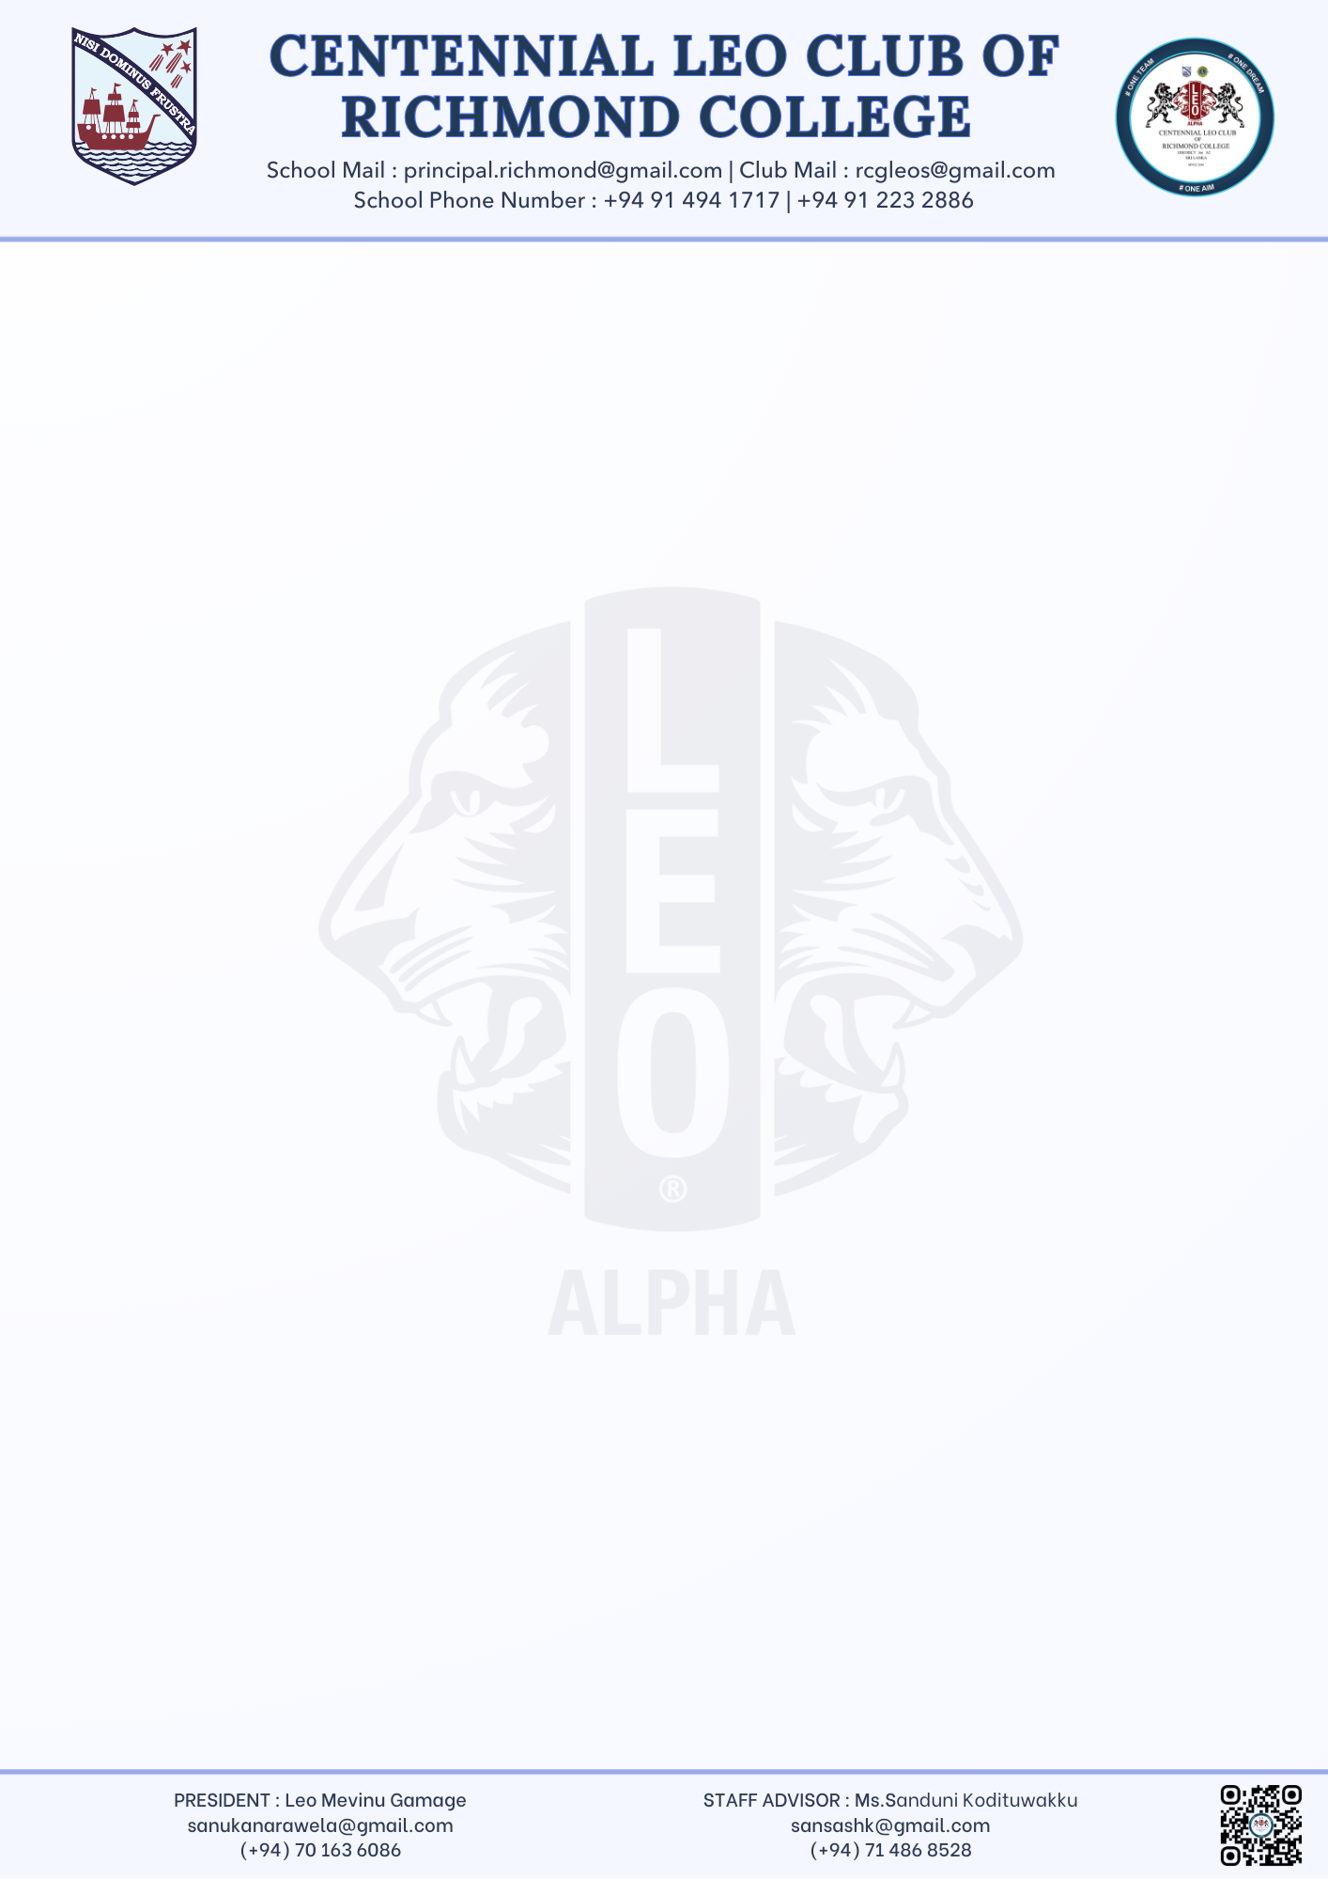

Mevinu Gamage,
President
Centennial Leo Club of Richmond College
26.09.2025
Principal
Richmond College, Galle

Dear Sir,
Request for Permission to Collect Sponsorships – “INSPIRATION’25”
We, the Centennial Leo Club of Richmond College, Galle, will be organizing our 10th Installation Ceremony and 10th Anniversary Celebration – “INSPIRATION’25” on 25th October 2025 at Richmond College.
In order to meet the financial requirements of this milestone event, we kindly request your permission to collect sponsorships and donations from external organizations, businesses, and well-wishers.
All collections will be done in an organized and transparent manner, under the supervision of the Staff Advisor, and proper acknowledgment will be given to sponsors during the event.
We sincerely look forward to your approval and guidance in this matter.
Thank you.
Yours faithfully,

………………………………………
Mevinu Sanuka Narawela Gamage
President – Leo Club
Richmond College, Galle

………………………………………
Ms. Sanduni Kodituwakku
Staff Advisor – Leo Club
Richmond College, Galle

